This report prepares the UCI credit card default dataset (30,000 customers, 22% default) for modelling. Recent repayment status is the strongest signal, and the six bill amounts are largely redundant. Using training data only, PCA and VIF reduced 28 columns to 20 leak-free features for CA2.
CA1 Report – Credit Card Default: EDA, Preparation, PCA, and Feature Selection
AI: Theory to Practice (TU862) · CA1 Pair Project · TU Dublin, Tallaght Campus
Hady Yousef (X00219585) Youssef Sakkaf (A00044025)

Pages (excluding title page, references and appendices): 10

Table of Contents
1. Introduction and problem 2
2. Data understanding and EDA 2
Structure 2
Summary statistics and missingness 3
Target 3
Relationships with default 3
3. Data cleaning and preparation 4
Identifier and duplicates 5
Undocumented codes 5
Train/test split 5
Outliers 5
Encoding 5
Transformation and scaling 5
4. Correlation, redundancy and multicollinearity 6
5. Principal Component Analysis 7
6. Feature selection 8
Filter checks 8
Dummy-variable trap 8
VIF Backward elimination 8
PCA against original columns 9
7. Data leakage and reproducibility 10
Order 10
Checks 10
Reproducibility 10
CA2 10
8. Final hand-over 10
9. Limitations and ethical considerations 11
Protected characteristics 11
Other limitations 11
References 11
Appendix A: GenAI usage declaration 14
Appendix B: Plagiarism and originality declaration 14
Appendix C: Contribution statement 14

1. Introduction and problem
The following project converts raw UCI credit card default data into clean, readable features which will be used later to predict whether a customer will default on the following month's payment. Our deliverables revolved around preparing the data for training and testing, along with the reasoning behind every choice or feature included in the dataset.
The dataset we selected contains 30,000 credit card customers from April to September 2005 (Yeh and Lien, 2009) originating from a Taiwanese bank. Each row contains 23 features as well as a binary target, "default payment next month", which is published under a CC BY 4.0 license (Yeh, 2009). The idea is to create an early-warning model that reduces the chances of a missed payment that can cost the lender money.
We conducted our work using six main steps, each relying on the findings of the previous steps:
- EDA (Exploratory data analysis) to understand the structures, distribution, and quality problems.
- Data cleaning and preparation: handling duplicates, any undocumented code, outliers, encoding, transformation, and scaling.
- Correlation, redundancy, and multicollinearity checks.
- PCA (Principal Component Analysis) on all six “bill-amount” columns.
- Feature Selection, ending in a 20-feature set.
- Reproducibility and Data leakage.
Our work was done using pandas in Python, scikit-learn as well as statsmodels. To avoid data leakage, we decided to split into training and test sets prior to the model learning from the data (GeeksforGeeks, n.d.a).

2. Data understanding and EDA
The data in our dataset is complete; however, it is imbalanced, heavily skewed, and contains many undocumented codes. Each one of our decisions moving forward was shaped by these findings we identified.

Structure
As mentioned, the file contains 30,000 rows, 25 columns of which include an ID, 23 features, as well as the target. Each column is stored as an integer, but for the columns, not every one of them is a measurement (Table 1). PAY_0 was renamed PAY_1 so that repayment columns can be numbered in an organized manner from 1-6, similar to the bill and payment columns.
Table 1: Variable Types
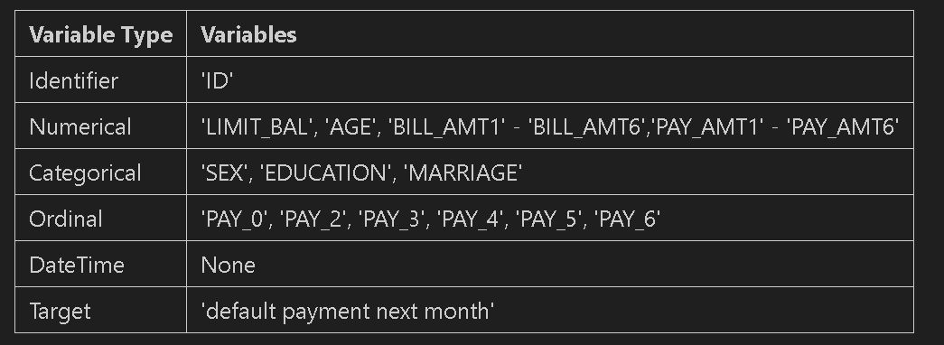

Summary statistics and missingness
No column contains missing values; therefore, no changes or replacements were needed. The scales widely differ, for instance; AGE goes from 21-79; LIMIT_BAL runs from 10,000 – 1,000,000 NT dollars with a standard deviation of around 129,700. The bill and payment amounts have long right tails in the histograms and box plots, pointing to transformation and scaling (W3Schools, n.d.c, n.d.e, n.d.g, n.d.h).

Target
23,364 customers (77.88%) did not default while 6,636 (22.12%) did. Due to the classes being imbalanced, the train/test split was stratified, and simply using the accuracy by itself would provide a misleading metric at the modelling stage.

Relationships with default
The strongest signal overall is the Recent repayment behaviour (Table 2). Customers that were two months late in September (PAY_1 = 2) defaulted 69.34% of the time in the training set, against 12.62% for PAY_1 = 0. PAY_1 had the highest correlation with a default result of (0.325), followed by the rest of the PAY columns ranging from results 0.183-0.264. LIMIT_BAL (-0.176) and PAY_AMT1 (-0.177) showed a negative correlation meaning customers with higher limits and larger payments defaulted less. Additionally, the bill amounts were almost unrelated to default (-0.007 to –0.023), as shown in Figure 1.
Table 2: Default rate by September repayment status (PAY_1), training set only
PAY_1 | Meaning | Customers | Default rate (%)
-2 | Undocumented (often read as "no consumption") | 2167 | 13.20
-1 | Paid on Time | 4528 | 16.98
0 | Undocumented (often read as "revolving credit") | 11820 | 12.62
1 | 1 month late | 2949 | 34.18
2 | 2 months late | 2143 | 69.34
3 | 3 months late | 250 | 77.20
All the default rates were calculated on the training, so no test rows shaped decisions carried later. The dataset also included demographic features and among them, EDUCATION "Others" stood out with a 7.41% default rate, against 19.56% - 24.85% for other levels. SEX 1 (male) defaulted 24.10% while SEX 2 (female) at 20.82%. Furthermore, MARRIAGE only ranged from 21.08% - 23.72%. The scatter plot of LIMIT_BAL against AGE showed no strong relationship.
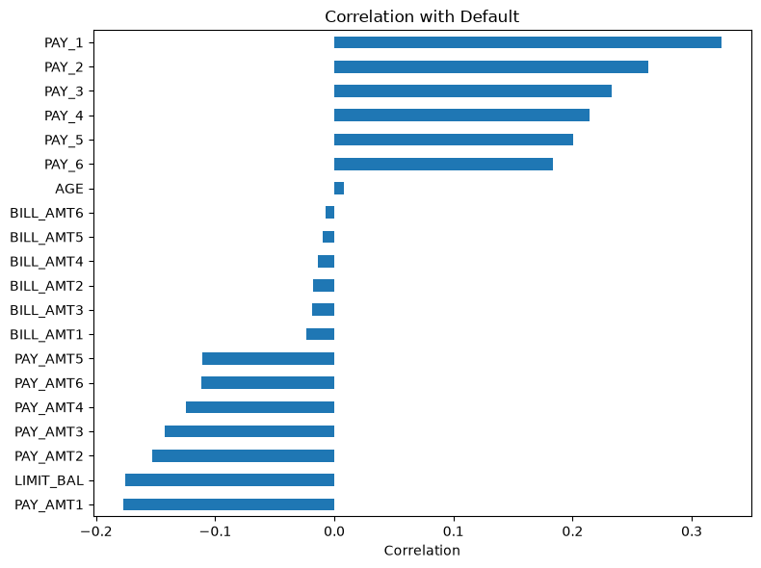Figure 1: Correlation of each feature with default (training data). Repayment status dominates; bill amounts are close to zero.

3. Data cleaning and preparation
The only things deleted were the ID column as well as the 35 duplicate rows. Every other fix kept the customer, and the values were reshaped instead.

Identifier and duplicates
All 30,000 IDs were unique; therefore, ID was dropped as a row number with no meaning. Having removed ID, we realized that 35 rows (0.12%) were exact copies of another row, mainly inactive accounts with every bill and payment displayed at 0. After removing them, the total rows were 29,965 (W3Schools, n.d.f).

Undocumented codes
EDUCATION 0, 5, and 6 and MARRIAGE 0 were not shown in the dataset's documentation. Since they were small groups (14, 280, 51, and 54 rows), we decided to merge them into the existing "Others" levels. The PAY codes –2 and 0 were also not shown in the documentation, even though 1,856 of the 2,750 customers with PAY_1 = -2 still had a bill above 0, which means the data was valuable; therefore, -2 was kept as its own value. Negative bill amounts (590 – 688 per month) were kept as credit balances.

Train/test split
Before moving to steps that learn from the data, rows were split into 80/20, stratified on the target (random_state = 42). This gave 23,972 training rows, 5,993 test rows, both with 22.13% defaults (W3Schools, n.d.b; Stack Overflow, 2016b).

Outliers
The IQR rule (1.5 x IQR) flagged few outliers in LIMIT_BAL (0.6%) and AGE (0.9%), but 7.9 - 10.0% in each bill and payment column (GeeksforGeeks, n.d.f). Box plots showed long tails of real customers rather than errors: ages were 21-79; each credit limit was positive with no negatives in any payment. The decision to keep outliers was made since in this case, deleting them would remove thousands of customers, including defaulters which are already in the minority. Capping was also rejected as it would make the largest payers look identical.

Encoding
SEX was recoded to a single 0/1 column (male = 0, female =1). EDUCATION and MARRIAGE were one-hot encoded, because their "Others" level has no place in an order, using a fixed list of levels, so the training and test set have identical columns (GeeksforGeeks, n.d.i; Stack Overflow, 2016a). PAY_1 – PAY_6 were kept as numbers because larger values means a longer delay.

Transformation and scaling
To compress the long right tail of LIMIT_BAL and PAY_AMT1-6, a log1p transform was applied (GeeksforGeeks, n.d.g). The zero Payments made by 17-24% of customers each month were handled by log1p. Skewness fell from 10.70 to 31.99 to between –1.30 and –0.86 for the PAY_AMT feature, and the same was for LIMIT_BAL, where it dropped from 1.00 to –0.52. A small left skew remained that comes from the zero payments. Log transformation was not applied to the BILL_AMT columns because they contained negative values. The training set had 28 columns after StandardScaler was fitted on the training set only and no changes were applied to the test set (W3Schools, n.d.a; GeeksforGeeks, n.d.b; Stack Overflow, 2014).

4. Correlation, redundancy and multicollinearity
The six bill columns look nearly identical to each other, and the repayment-status columns overlap strongly too.
On the training set, the bill-amount columns correlate at 0.80 - 0.96 (Figure 2; W3Schools, n.d.d; GeeksforGeeks, n.d.d). Neighbouring months correlate most, for instance, BILL_AMT1 and BILL_AMT2 at 0.96, since a customer's balance changes slowly monthly. The PAY columns correlate at 0.47 - 0.82, with PAY_4 – PAY_5 and PAY_5 – PAY_6 both at 0.82. The payment amounts are only lightly related to each other (0.35 - 0.5). These are associations, not causes.
To measure how well one feature can be predicted from the others, the Variance Inflation Factor (VIF) was used. Having a VIF above 5 is a common warning sign, and serious multicollinearity is visible if it exceeds 10 (GeeksforGeeks, n.d.c). The bill scored 10.66 - 17.95 on the 14 numerical features, while the other features stayed below 1.8.
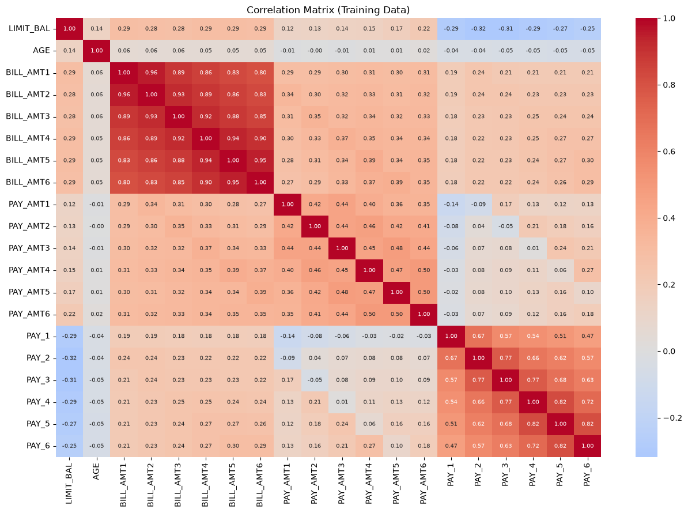
Figure 2: Correlation matrix (training data). The red block in the top-left is the six bill amounts; the block in the bottom-right is the six PAY columns.
Each correlated column might still add signal, so they were not dropped yet; through Sections 5 and 6, PCA and VIF elimination, these were handled.

5. Principal Component Analysis
90.6% of the variance in the six bill columns was captured through one principal component, and the size of the customer's balance is measured.
PCA was applied solely to the six BILL_AMT columns, as they formed the redundant block found in section 4. The bill columns it used were already standardized by the training-fitted scaler, as PCA is sensitive to scale (GeeksforGeeks, n.d.e) . PCA was fitted on the training set and then applied to the test set.
PC1 explains 90.6% of the variance, and PC2 explains further 5.1%, being 95.7% together (Figure 3). Having One component was enough to pass the chosen 90% threshold.
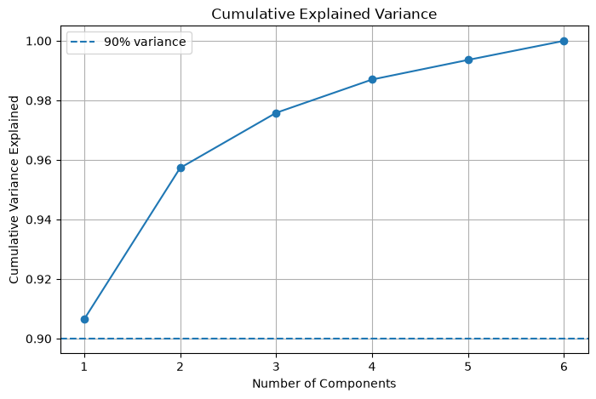
Figure 3: Cumulative explained variance. PC1 alone passes the 90% line.
Each component is explained through the loadings (Stack Overflow, 2017):
- Almost equal positive loadings on all six months are from PC1 (0.401 - 0.415). This is the customer's overall balance level.
- PC2 runs from +0.533 on BILL_AMT1 (September) to –0.530 on BILL_AMT6 (April). It contrasts the recent as well as older balances, displaying whether a balance grew or shrank.
Predictive power isn't what PCA keeps; rather, it keeps variance. At only -0.016 does BILL_PC1 correlate with the default and is slightly weaker than BILL_AMT1 at –0.023. So, during feature selection, PC1 was treated as a candidate feature and compared against the original columns.

6. Feature selection
Four checks reduced the 28 prepared columns to 20 features.

Filter checks
There was no feature selection that was constant. EDUCATION_4 and MARRIAGE_3 were near - constant (98.4% and 98.7% zeros) but were kept, as EDUCATION_4 customers default at 7.41% against 22.13% overall in the training set, so the rare value carries signal.

Dummy-variable trap
Inside each one-hot group, the dummies always result in a sum of 1, so any of the dummies can be calculated from the rest. This is a perfect multicollinearity for linear models. EDUCATION_1 (graduate school) and MARRIAGE_1 (married) were dropped and became the reference levels, leaving 26 columns (GeeksforGeeks, n.d.h).

VIF Backward elimination
On the 20 numerical and PAY features, the ones with the highest VIF were removed, VIF was then recalculated and this repeated until every single value went below 5 (Table 3.) SEX and dummies were left out since the trap problem was already resolved. Recalculating after each removal is crucial. Once the BILL_AMT2 was removed, BILL_AMT1 fell from 11.82 to 5.45, and once PAY_5 was gone, PAY_4 fell from 5.92 - 4.42. The highest remaining VIF was 3.29 (BILL_AMT6)
Table 3: Order of removal in VIF backward elimination
Step | Feature removed | VIF when removed
1 | BILL_AMT2 | 18.05
2 | BILL_AMT5 | 17.03
3 | BILL_AMT4 | 11.16
4 | BILL_AMT3 | 6.92
5 | PAY_5 | 6.35
6 | PAY_3 | 5.11
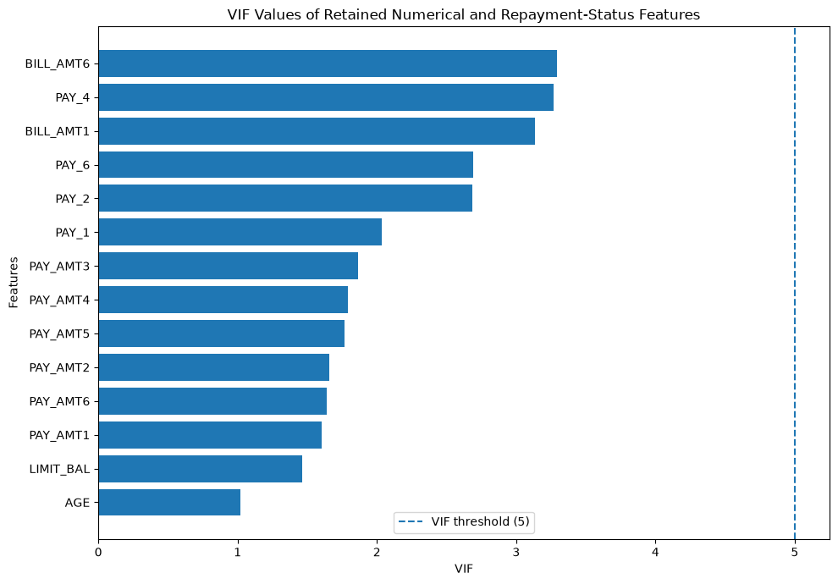
Figure 4: VIF of the 14 retained numerical and repayment-status features. All are below the threshold of 5.

PCA against original columns
BILL_PC1 was not used. It is no more related to default than BILL_AMT1 (-0.016 against –0.023), and a mix of six months is harder to explain than one month's bill. Keeping BILL_AMT1 and BILL_AMT6 preserves both the balance level (PC1) and its changes over time (PC2).

Table 4: Feature decisions
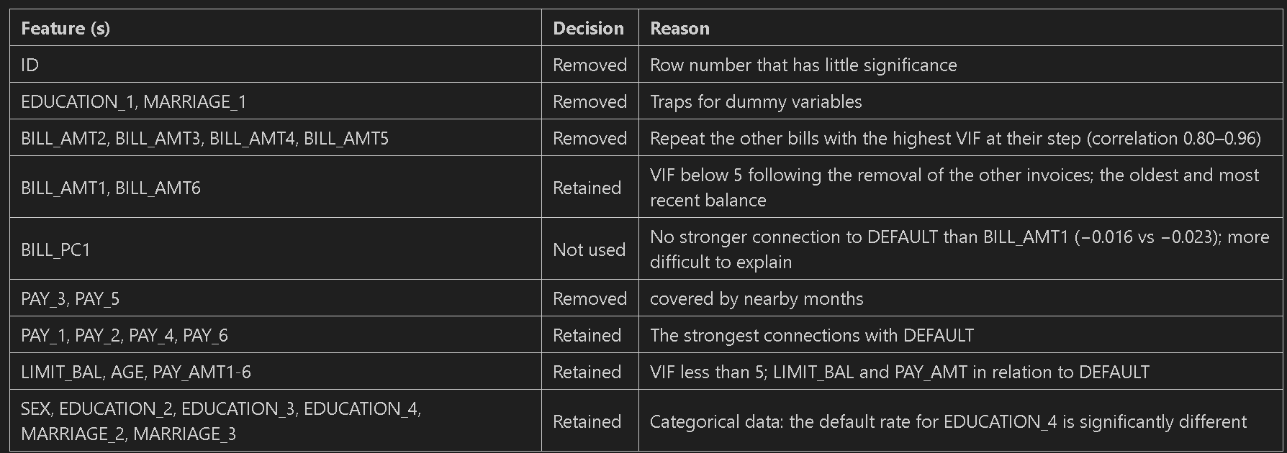

7. Data leakage and reproducibility
Every step that learns from the data was fitted on the training set only, and the test set made no decisions.

Order
Before splitting the data, the steps taken (dropping ID, removing duplicates, and merging codes) are fixed rules that learn nothing, so they would have to be applied identically to any new customer. The IQR bounds, default rates, scaler, correlations, VIF, and PCA were learned from the training set and applied unchanged to the test set after the split (GeeksforGeeks, n.d.a).

Checks
The notebook includes three checks that support this (W3Schools, n.d.i). In both sets, no row appears. The target isn’t revealed by any feature: April – September 2005 is described through every feature, October payment is the target, and the strongest correlation with default is 0.325 (PAY_1), far from 1. The EDUCATION_4 rate was recalculated on training data only (7.41%) to keep that feature.

Reproducibility
Stratified splitting was used with random_state = 42, both sets always get the same columns because the category lists are fixed, and the notebook runs normally from top to bottom in one order.

CA2
Every fitted step will be refit inside each training fold, ideally with a scikit-learn Pipeline, and until the final evaluation, the test set will remain untouched during cross-validation.

8. Final hand-over
X_train_final (23,972 x 20) and X_test_final (5,993 x 20) are handed over to the modeling stage, with targets y_train and y_test at 22.13% default each.
Table 5: Final hand-over feature set (4 repayment-status, 9 amount and 7 profile features)
Group | Final features
Repayment status | PAY_1, PAY_2, PAY_4, PAY_6
Amounts | LIMIT_BAL, BILL_AMT1, BILL_AMT6, PAY_AMT1-6
Profile | AGE, SEX, EDUCATION_2, EDUCATION_3, EDUCATION_4, MARRIAGE_2, MARRIAGE_3
This order must be repeated for the preprocessing on any new data: merge the undocumented codes, recode SEX, one-hot encode with the fixed levels, apply log1p to LIMIT_BAL and PAY_AMT1-6, then apply the StandardScaler fitted on the training set.

9. Limitations and ethical considerations

Protected characteristics
SEX, MARRIAGE and maybe AGE do not describe how a customer manages credit it describes who a customer is. Anti-discrimination laws protect against using these characteristics in a lending decision since they could affect how a person is treated. AI systems are classed as high-risk if they assess the creditworthiness of individuals (Regulation (EU) 2024/1689, Annex III). For the modelling stage to measure their effect, these features were kept. However, the dummies for SEX and MARRIAGE only correlate with default at 0.004-0.039 in absolute terms, so dropping them would likely cost little. Our recommendation is to test the model without them and check error rates across groups.

Other limitations
- Between -2, -1 and 0, treating PAY codes as numbers assumes equal steps, whose meanings are undocumented. Alternatives worth testing could be, One-hot encoding or a simple "any delay" flag.
- Merging the undocumented EDUCATION and MARRIAGE codes in "Others" is not a documented fact but an assumption.
- A rule of thumb is the VIF threshold of 5, but a threshold of 10 would have also kept BILL_AMT3, PAY_3 and PAY_5.
- VIF and Correlation only capture linear relationships. Model-based selection, such as permutation or L1 regularisation, could refine the set in CA2.
- Patterns may not transfer to other markets or to today's lending as the data only comes from a Taiwanese bank in 2005.

References
European Parliament and Council of the European Union (2024) Regulation (EU) 2024/1689 laying down harmonised rules on artificial intelligence (Artificial Intelligence Act). Official Journal of the European Union, L series, 12 July. Available at: https://eur-lex.europa.eu/eli/reg/2024/1689/oj.
GeeksforGeeks (n.d.a) Data Leakage. Available at: https://www.geeksforgeeks.org/machine-learning/data-leakage/ (Accessed: 3 November 2026).
GeeksforGeeks (n.d.b) Data Pre-Processing with Sklearn using Standard and Minmax Scaler. Available at: https://www.geeksforgeeks.org/machine-learning/data-pre-processing-wit-sklearn-using-standard-and-minmax-scaler/ (Accessed: 3 November 2026).
GeeksforGeeks (n.d.c) Detecting Multicollinearity with VIF – Python. Available at: https://www.geeksforgeeks.org/python/detecting-multicollinearity-with-vif-python/ (Accessed: 3 November 2026).
GeeksforGeeks (n.d.d) How to Create a Seaborn Correlation Heatmap in Python? Available at: https://www.geeksforgeeks.org/python/how-to-create-a-seaborn-correlation-heatmap-in-python/ (Accessed: 3 November 2026).
GeeksforGeeks (n.d.e) Implementing PCA in Python with scikit-learn. Available at: https://www.geeksforgeeks.org/machine-learning/implementing-pca-in-python-with-scikit-learn/ (Accessed: 3 November 2026).
GeeksforGeeks (n.d.f) Interquartile Range to Detect Outliers in Data. Available at: https://www.geeksforgeeks.org/machine-learning/interquartile-range-to-detect-outliers-in-data/ (Accessed: 3 November 2026).
GeeksforGeeks (n.d.g) Log Transformation. Available at: https://www.geeksforgeeks.org/data-science/log-transformation/ (Accessed: 3 November 2026).
GeeksforGeeks (n.d.h) ML | Dummy Variable Trap in Regression Models. Available at: https://www.geeksforgeeks.org/machine-learning/ml-dummy-variable-trap-in-regression-models/ (Accessed: 3 November 2026).
GeeksforGeeks (n.d.i) One Hot Encoding in Machine Learning. Available at: https://www.geeksforgeeks.org/machine-learning/ml-one-hot-encoding/ (Accessed: 3 November 2026).
Stack Overflow (2014) What is the difference between 'transform' and 'fit_transform' in sklearn? Available at: https://stackoverflow.com/questions/23838056 (Accessed: 3 November 2026).
Stack Overflow (2016a) How to encode two Pandas dataframes according to the same dummy vectors? Available at: https://stackoverflow.com/questions/39970517 (Accessed: 3 November 2026).
Stack Overflow (2016b) Parameter "stratify" from method "train_test_split" (scikit-learn). Available at: https://stackoverflow.com/questions/34842405 (Accessed: 3 November 2026).
Stack Overflow (2017) PCA on sklearn – how to interpret pca.components_. Available at: https://stackoverflow.com/questions/47370795 (Accessed: 3 November 2026).
W3Schools (n.d.a) Machine Learning – Scale. Available at: https://www.w3schools.com/python/python_ml_scale.asp (Accessed: 3 November 2026).
W3Schools (n.d.b) Machine Learning – Train/Test. Available at: https://www.w3schools.com/python/python_ml_train_test.asp (Accessed: 3 November 2026).
W3Schools (n.d.c) Pandas – Analyzing DataFrames. Available at: https://www.w3schools.com/python/pandas/pandas_analyzing.asp (Accessed: 3 November 2026).
W3Schools (n.d.d) Pandas – Data Correlations. Available at: https://www.w3schools.com/python/pandas/pandas_correlations.asp (Accessed: 3 November 2026).
W3Schools (n.d.e) Pandas – Plotting. Available at: https://www.w3schools.com/python/pandas/pandas_plotting.asp (Accessed: 3 November 2026).
W3Schools (n.d.f) Pandas – Removing Duplicates. Available at: https://www.w3schools.com/python/pandas/pandas_cleaning_duplicates.asp (Accessed: 3 November 2026).
W3Schools (n.d.g) Pandas DataFrame describe() Method. Available at: https://www.w3schools.com/python/pandas/ref_df_describe.asp (Accessed: 3 November 2026).
W3Schools (n.d.h) Pandas DataFrame skew() Method. Available at: https://www.w3schools.com/python/pandas/ref_df_skew.asp (Accessed: 3 November 2026).
W3Schools (n.d.i) Python Set intersection() Method. Available at: https://www.w3schools.com/python/ref_set_intersection.asp (Accessed: 3 November 2026).
Yeh, I.-C. (2009) Default of Credit Card Clients [Dataset]. UCI Machine Learning Repository. doi: 10.24432/C55S3H.
Yeh, I.-C. and Lien, C.-H. (2009) 'The comparisons of data mining techniques for the predictive accuracy of probability of default of credit card clients', Expert Systems with Applications, 36(2), pp. 2473–2480. doi: 10.1016/j.eswa.2007.12.020.

Appendix A: GenAI usage declaration
We used Claude (Anthropic) during this project. We used it to:
- We asked Claude to review our notebook to point out if there were any inconsistencies, which we then did research to find out how to fix them
- Claude assisted us in understanding why some errors were happening in the code
- Claude helped suggest the structure of the data leakage checks in Section 7, which we then understood and figured out how to fix them and rerun;
- We used AI to download the template needed for our presentation.

Appendix B: Plagiarism and originality declaration
We declare that this report, the accompanying notebook and the presentation are our own work, except where sources are cited in the References and where GenAI use is declared in Appendix A. We have not submitted this work for any other module or assessment.
Name | Student Number | Date
Hady Yousef | X00219585 | 03/11/2026
Youssef Sakkaf | A00044025 | 03/11/2026

Appendix C: Contribution statement
Both members reviewed the full notebook and report and could answer questions on any part of the project.

Member | Main Contribution
Hady Yousef | EDA, data cleaning and preparation, report sections 1-4, presentation part A
Youssef Sakkaf | Correlation and VIF, PCA, Feature selection, data leakage checks, report sections 5-9, presentation part B

